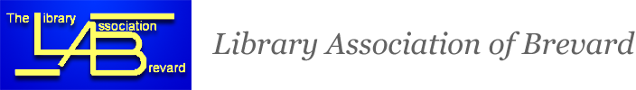

December, 2019
LAB Fall/Winter Educational Meeting
On Friday, December 6, 2019 Eleven LAB members met at Kennedy Space Center Headquarters for a small group tour of the KSC/NASA Library.
The tour was conducted by Debbie Guelzow, retired librarian, around 1 p.m. after members were given badges and received clearance from the Badging Station.
Debbie escorted the group into the very new Headquarters Building , built recently next to the old headquarters building from the 1960”s. The library collection itself, Debbie explained, was recently condensed down to about a third, and moved into the new building from the old one this past year. What remains are the photgraph collection in one room, and the books housed in another. The library offers checkout to staff working there, as well as other agencies. E-books are now being used more heavily. Some databases available include ProQuest, AccessEngineering, etc. for staff needing information on projects, etc. Debbie introduced us to Lori Uffiner, staff member there at the library, who assisted with the tour, showing us the shelving units with the books available. Titles included GRE exam books, books on leadership such as Lean In for Graduates, Lincoln on leadership, the Outlook Occupational Handbook, Gallery of Best Resumes for job seekers, etc. Lori and Debbie then took the group to the 7th floor, where members could see the launch pads through the many panes of glass, enabling staff to have a bird’s eye view of launches and rockets!
Afterward, the group gathered on the first floor to spend time in the gift shop before departing.
Group picture is shown below. (With Thanks to LAB President Marian for helping to organize this tour).
Any further information about LAB events or offices will be given out thru the LAB list-serv.
Respectfully submitted,

Secretary, LAB Lynn Bennett
Page one
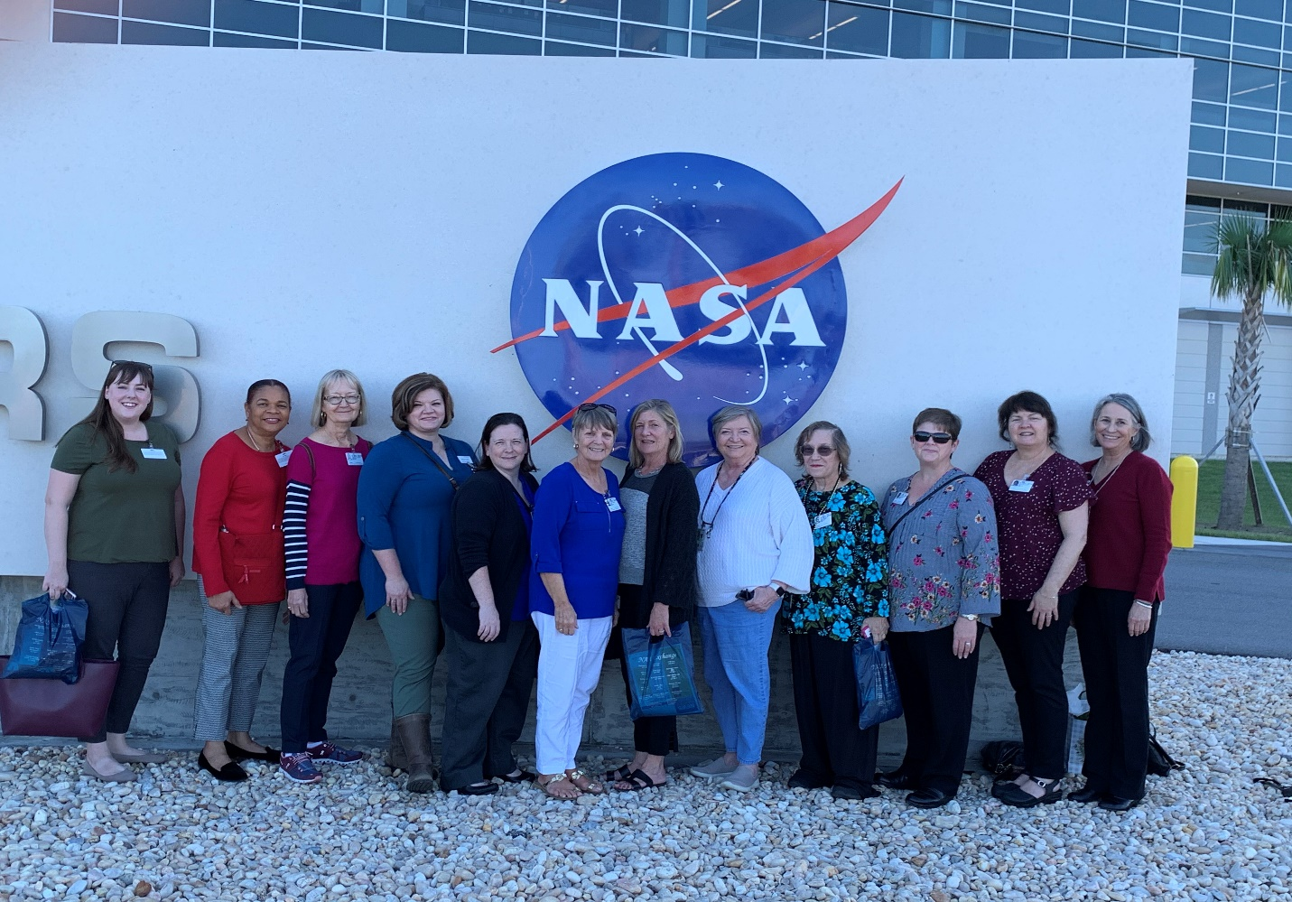
Page two

